20. Plant Biology III: Reproduction *(RHM: Chapter 36)*

______________________________________________________________________________

I. Modes of Reproduction *(853-854)*

II. Sporophytes and the Production of Gametophytes *(854-859)*

A. Alternation of Generations

1. Sporophytes

2. Gametophytes

B. Development of Male Gametophyte

1. Microsporocytes

2. Microspores and pollen grains

3. Pollen nuclei

C. Development of Female Gametophyte

1. Megasporocytes

2. Megaspores

III. Pollination and Fertilization *(859-862)*

A. Pollination

1. Definition

2. Agents and mechanisms

B. Fertilization

1. Germination of pollen

2. Double fertilization

IV. Angiosperm Seeds and Fruit *(862-865)*

A. Endosperm

B. Embryo Development

1. Production of embryo

2. Production of suspensor

3. Polarity in the embryo

C. Seed Structure

1. Embryo

2. Seed coat

3. Embryonic axis

D. Fruit Development

1. Growth and ripening

2. Types of fruits

3. Fruits and seed dispersal

V. Seed Germination *(865-868)*

A. Seed Dormancy

B. Germination

1. Imbibition

2. Mobilization of energy reserves

3. Emergence of root and shoot

20-1

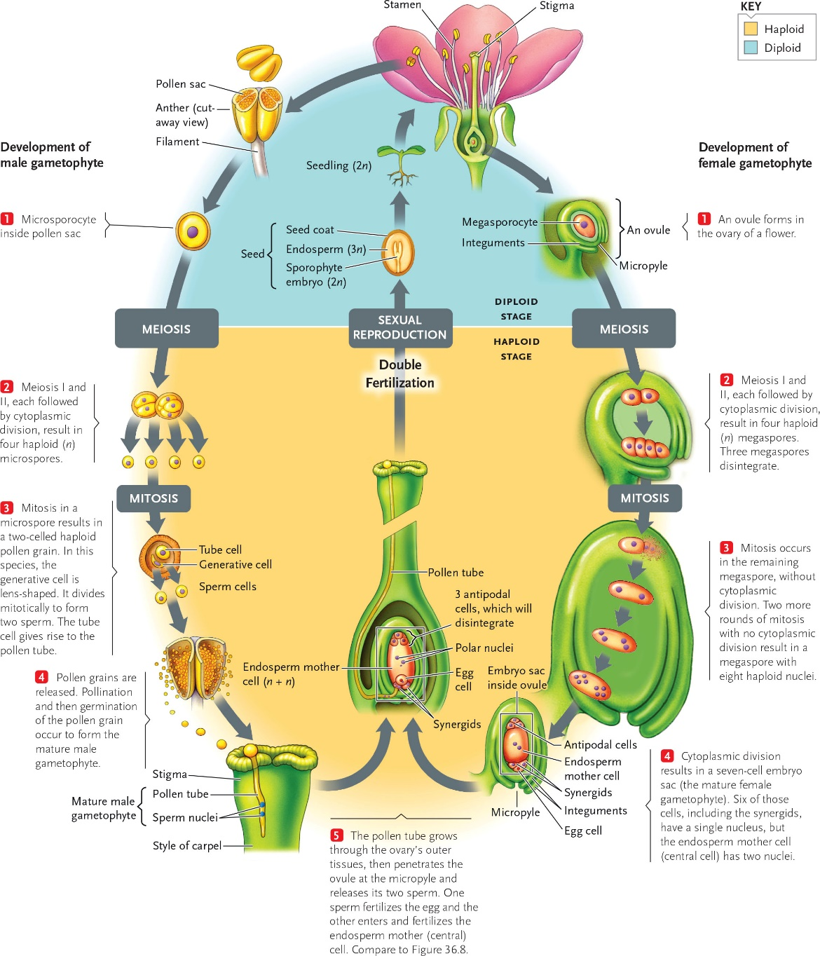

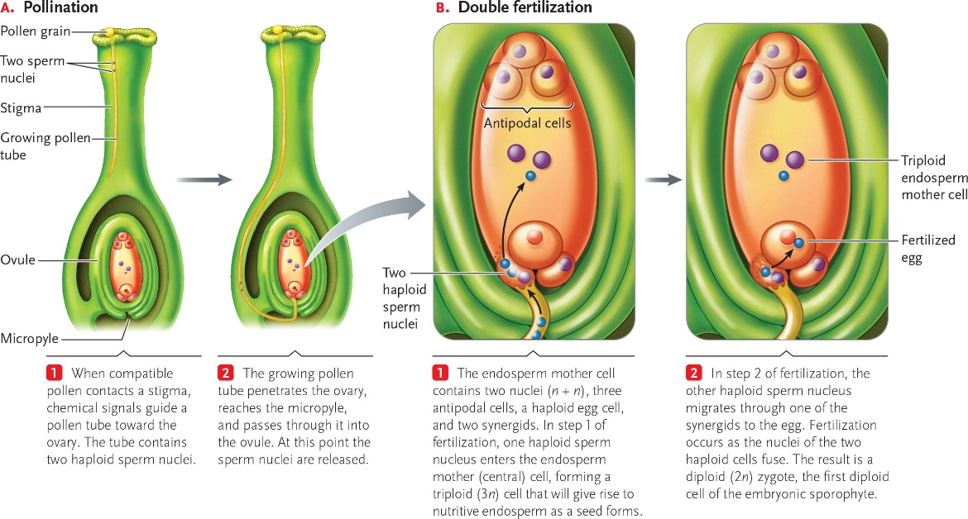

20-2

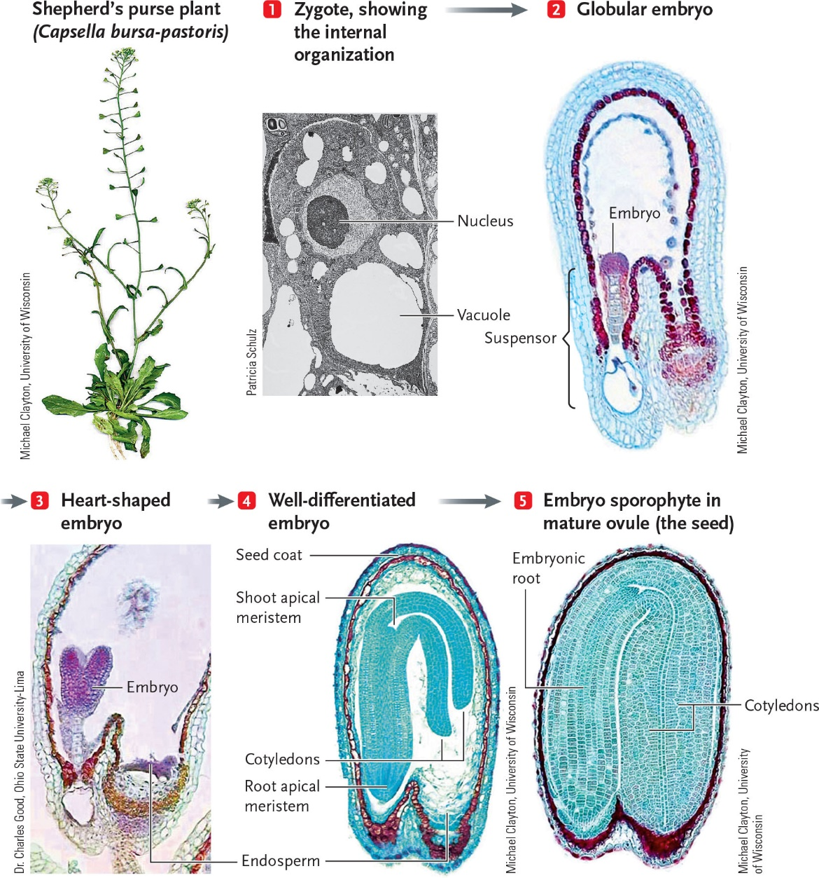

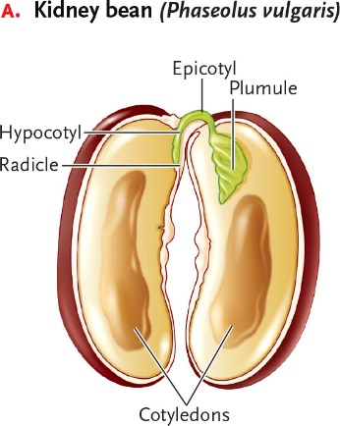 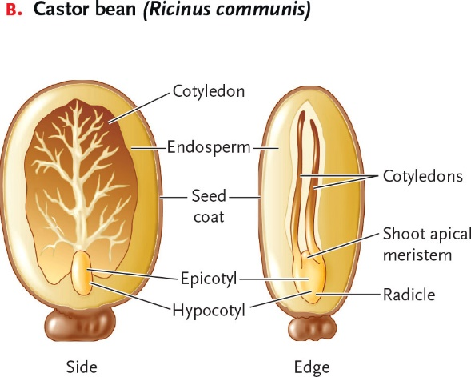 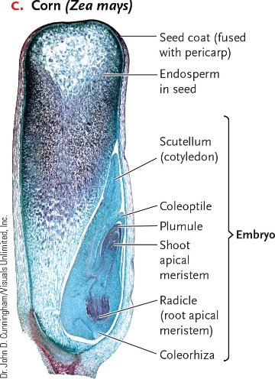

20-3

